**Sprint 1 (Planned in 1 one sprint):**

1. **Sprint planning and task completion**:

* Understanding the problem statement.
* Collecting the requirement.
* Creating the flow of application.
* Initialized the GIT repo.
* Writing the pseudo code.
* Writing the java program/developing a solution to fulfill the project requirement.
* Testing the project developed on various inputs.
* Push the code on GitHub.

1. **Core concepts:**

* File handling
* Collections
* Exception handling
* Sorting
* Flow control

1. **Demonstration:**

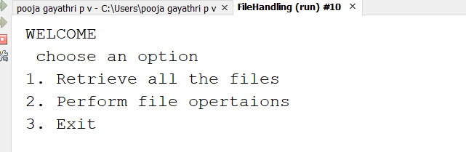

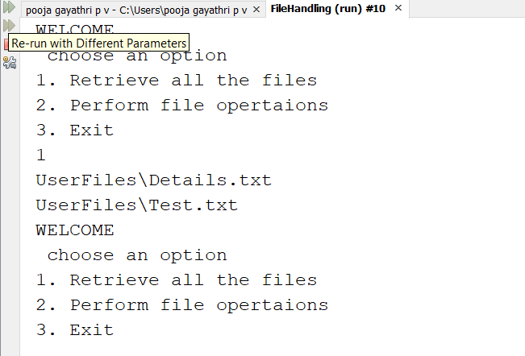

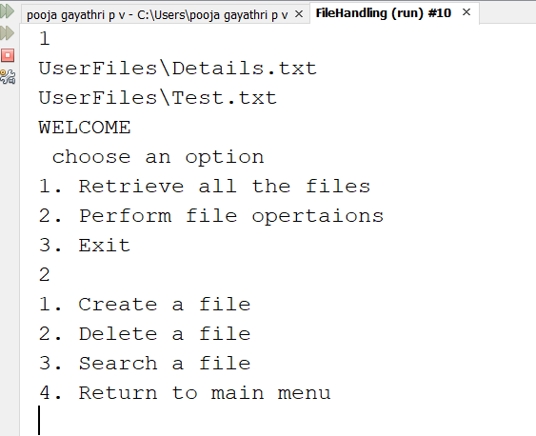

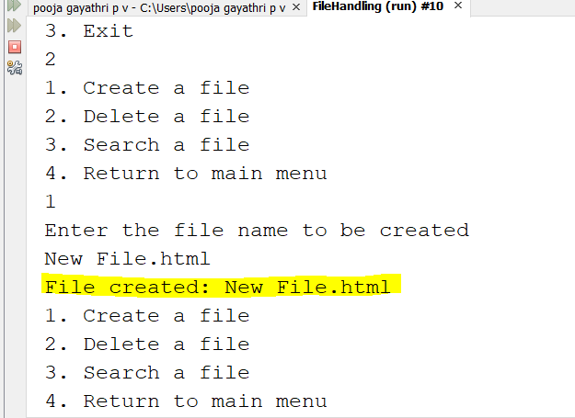

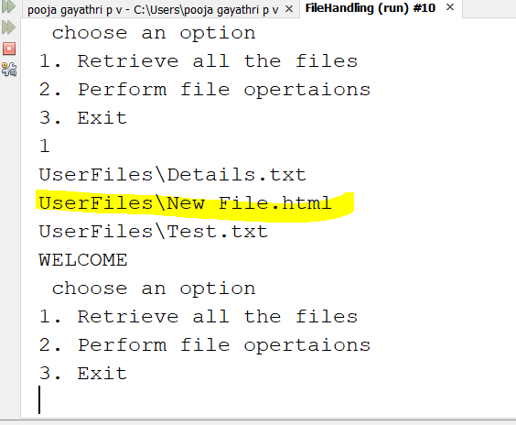

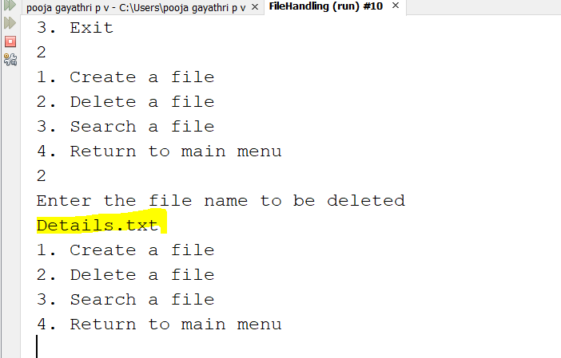

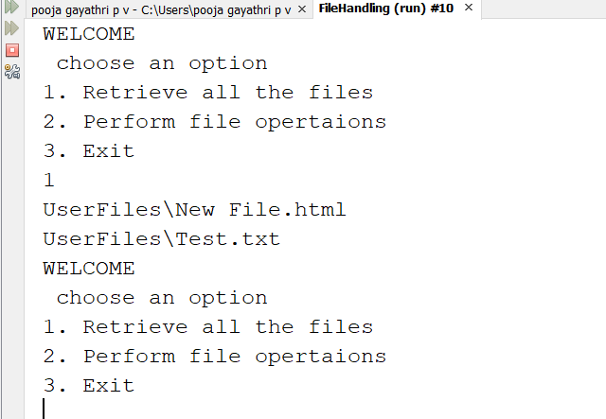

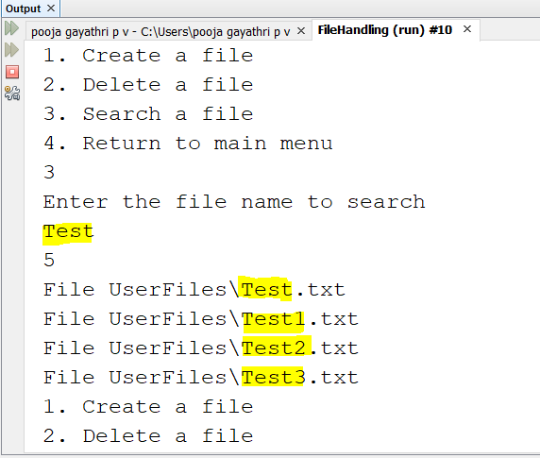

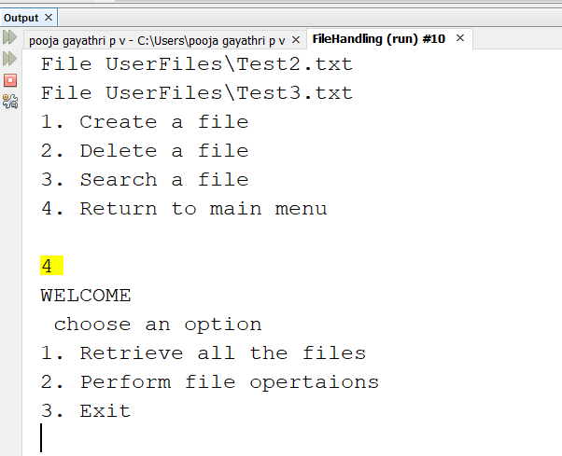

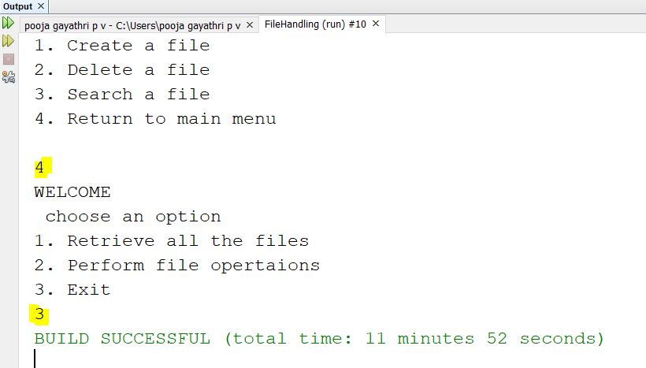

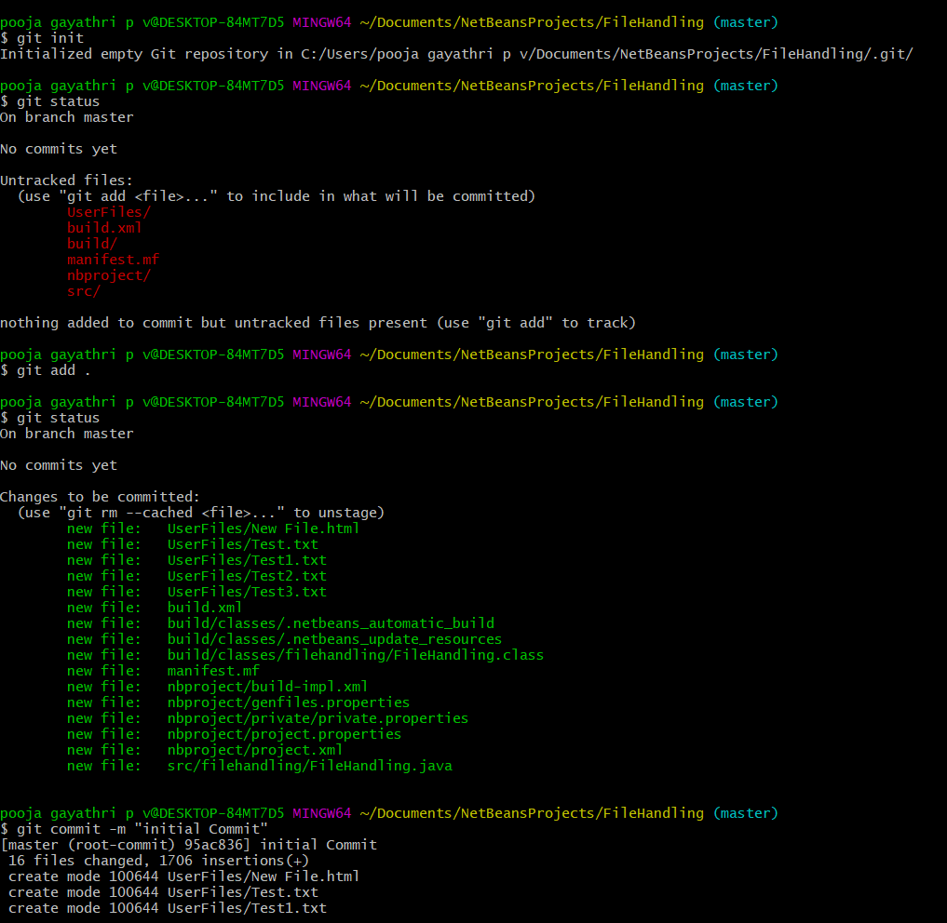

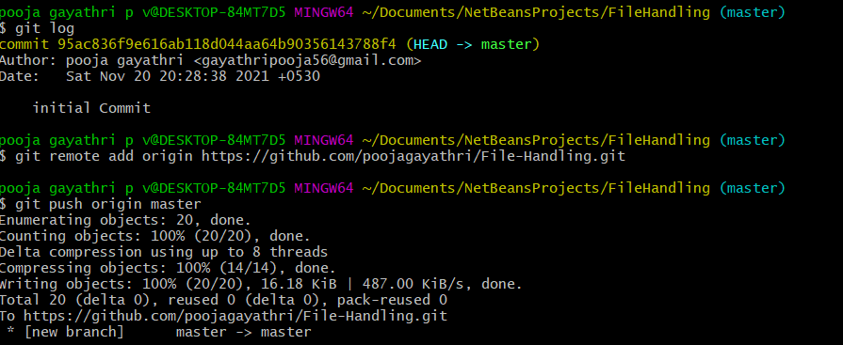

**Link to GitHub Repo**:

https://github.com/poojagayathri/File-Handling

**Conclusion:**

The project performs file handling operations such as creating a folder/file , deleting a file and searching for files using core java concepts like collections and sorting.